**Mate**

**CURATE your Course Materials w/ Open Educational Resources and/or**

**Library Licensed Resources.**

**REIMAGINE YOUR TEXTBOOK!**

* **Replace** a high-cost textbook with an open access alternative.
* **Reuse, Remix, Revise open educational resources (OERs) or other authoritative freely available content**.

Open Educational Resources (OERs) are teaching, learning, and research resources released under an open license that permits their free use and repurposing by others. OERs can be textbooks, full courses, modules, videos, tests, software, or any other tool, material, or technique that supports access to knowledge.

* **Replace** a textbook by linking to **Library** e-books, book chapters, essays, scholarly journal articles, images and thousands of streaming audio and videos. **O**

**PEDAGOGICAL BENEFITS**

* Studies have shown that OERs often contain multimedia content that increases comprehension, retention, and creates learning stimuli. Multimedia enhances and illustrates concepts and examples in a way that static textbooks do not.
* Easy to customize, offer multiple perspectives and up-to-date information.
* Empower your students in their learning by inviting them to submit open content to be reviewed by you for inclusion. Teach them analytical skills, how to evaluate information and improve their digital literacy.
* Increased access to course content via mobile devices.

**ALTERNATIVE TEXTBOOKS CREATED BY YOUR COLLEAGUES**

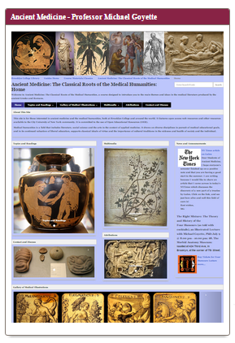



Developing an OER site has allowed me to customize the content of my course and teach it in a way that is directed toward the particular needs of my students. My OER site also asks for students to contribute annotated multimedia content as part of a course assignment. My students have risen to the occasion with excellent contributions, and I believe that the act of contributing to a publicly-visible academic website has been a very empowering experience for them.

**Professor Michael Goyette**

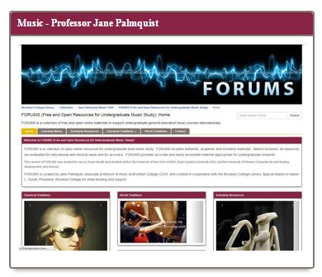

OERs enrich teaching and learning immeasurably, drawing from open, authentic, scholarly materials and primary sources worldwide with interactive capabilities beyond those of commercial materials. OERs are flexible and can be easily adapted and updated to include new material, and to reflect students’ needs and interests, or a professor’s specific philosophy and approach. My OER is now incorporating international contributions in partnership with colleagues across the world—furthering our students’ and Brooklyn College’s niche in the global community of scholars. My students are especially excited about a portal to music apps so that they can create their own music online. One student even created an app to add to the site for future students—reflecting a real ownership in the course materials.

**Professor Jane Palmquist**

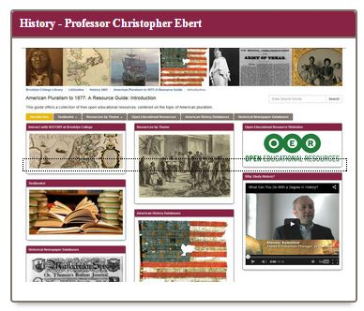

The History Department created an OER to support a general education course that’s been taken by thousands of students. The OER can reduce students’ costs and also ease preps for the many full and part-time faculty teaching the course.

**Professor Christopher Ebert**

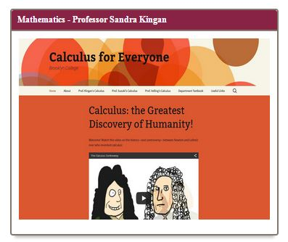 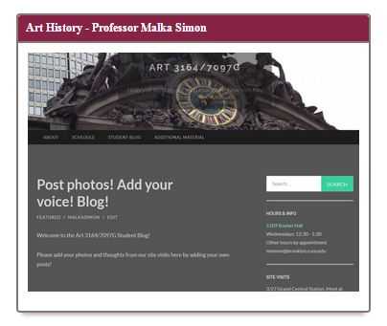

**View BC Alternative Textbooks @**

**http://libguides.brooklyn.cuny.edu/oeralt**

**The Brooklyn College Library and the Center for Teaching have partnered**

**to provide you with instructional designers for your alternative textbook.**

**Please contact Professor Miriam Deutch at MiriamD@brooklyn.cuny.edu or**

**Professor Brian Sowers at BSowers@brooklyn.cuny.edu.**

**if you would like assistance in creating an alternative textbook!**

Free textbooks reduce the income inequality among students.

**Professor Sandra Kingan**

My OER gives my students access to an incredible variety of resources: print, visual, and multimedia.  It allows us the flexibility to reference text and images on the go, and is an integral part of our weekly site visits.  The OER is interactive, inviting student contributions and is instrumental in extending the learning experience beyond the classroom.  It has allowed us to create a virtual community where students continually document their experiences and ideas about architecture around New York.

**Professor Malka Simon**